Former NASA Astronaut Will Speak at Engineers' Week Banquet
Museum of Flight CEO Dr. Bonnie J. Dunbar to share inspirational stories

Richland, Wash., February 6, 2006 — National Engineers Week, now in its 55th year, will be observed February 19–25. The focus of the event is to educate and excite youth about the wonders of engineering and science.

In Richland, the special guest speaker at the local headquarters for the 2006 Engineers' Week: Connecting Educators to Engineering will be Dr. Bonnie J. Dunbar, the new president and CEO of The Museum of Flight and a former NASA astronaut who flew five shuttle missions. The local Engineer of the Year award will also be presented at the event. The banquet will be held at the Shilo Inn in Richland, Wash., on Saturday, Feb. 24. The social begins at 5:30 p.m.; dinner will commence at 6:15 p.m. Banquet tickets to are $35 each, or $30 for students and seniors. The ticket price includes a donation to The Museum of Flight. To purchase tickets, please e-mail
Cherri_Defigh-Price@rl.gov or call 509-373-9596.

Annually, more than 7,000 children in the Tri–Cities’ community are positively impacted by these educational activities. Each year, the Hanford Engineers Week committee hosts a variety of science and engineering-based activities, which educate and excite young people about the wonders of engineering. These programs include science exhibits, poster competitions and classroom presentations, providing students firsthand experience with engineering and its impact on the world around them.

For more information about National Engineers Week, please visit www.discoverengineering.org, or www.eweek.org. To learn more about The Museum of Flight, please check www.museumofflight.org.

Please note: High-resolution images of Dr. Dunbar are available to the media; please contact Eden Hopkins at ehopkins@museumofflight.org or 206-768-7105.
Dr. Bonnie J. Dunbar

Photo courtesy: The Museum of Flight
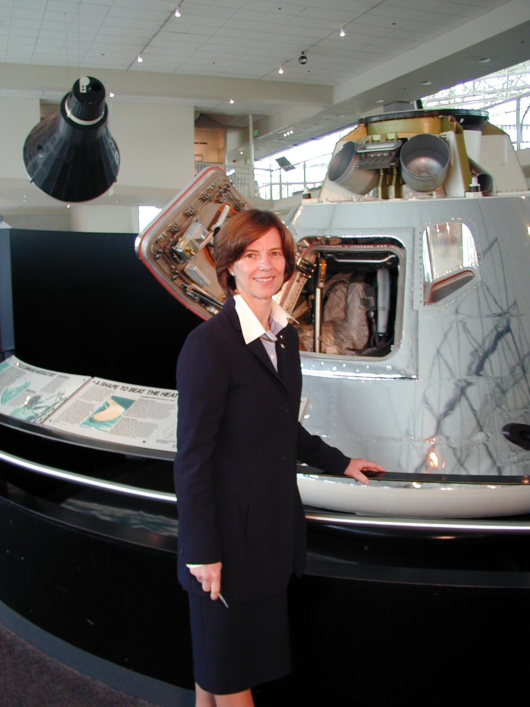

###

Media contact: Renee Slocum
Bechtel National
509-371-3213
rcslocum@bechtel.com

