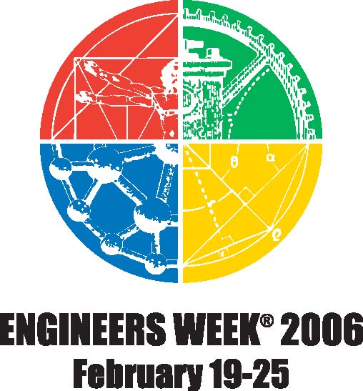
Connecting Educators
To Engineering

Engineers’ Week Banquet

Hosted by the Society of Women Engineers
Engineer of the Year Award Presented by WSPE

Featuring Dr. Bonnie J. Dunbar, PE
President and CEO Museum of Flight,
Former NASA Astronaut

Friday, February 24, 2006
Shilo Inn, Richland

Social 5:30 PM
Dinner 6:15 PM
Program 7:00 PM

Ticket Price $35 ($30 student/retired)
Ticket price includes donation to Museum of Flight

For Tickets or information, contact Cherri DeFigh-Price
Cherri_Defigh-Price@rl.gov
509-373-9596

Learn more at www.eweek.org
Dr. Bonnie L. Dunbar is the President and CEO of the Museum of Flight, one of the largest air and space museums in the world. A native of the small, south-central Washington rural community of Outlook, Dunbar earned bachelor's and master's degrees in ceramic engineering from the University of Washington and a doctorate in mechanical/biomedical engineering from the University of Houston. She held research and engineering positions with the Boeing Co., Harwell Laboratories and Rockwell International until 1978, when she joined NASA as a flight controller. Two years later she was selected as a NASA mission specialist astronaut. A veteran of five space flights, Dr. Dunbar has logged more than 1,208 hours (50 days) in space. Dr. Dunbar resigned from NASA in September 2005 to serve as President and CEO of the Seattle Museum of Flight in Seattle, Washington.

