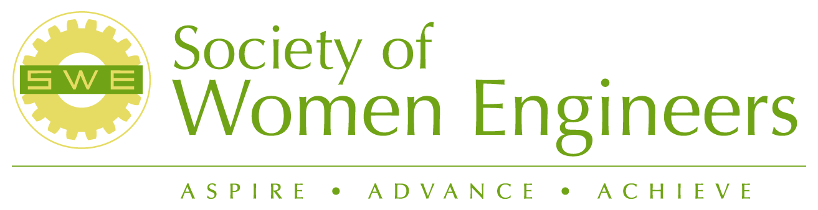

Society of Women Engineers – Eastern Washington Section
P.O. Box 364 Richland, WA 99352 www.swe.org Region J001

Inside this Issue
Society of Women Engineers – Eastern Washington Section 1
Inside this Issue 1
Upcoming Events 1
A Letter from SWE-EWS President 1
FY 06-07 Officer Contact List 2
Webinars Update 3
SWE Professional Development Programming 3
More Events and Announcements 6
Region J Conference Highlights 8
Engineers Make Things Work 9
Mentor a Middle School Girl via E-mail 10
SWE Scholarship Winners 11
Expanding Your Horizons 12
Happy July 4th! 12

Upcoming Events

June 28, 2006 SWE Board Meeting , Wednesday, 5:30 p.m.
June 24, 2006 SWE Year End BBQ , Saturday, 4:00 p.m.
August, 2006 SWE Retreat

A Letter from SWE-EWS President

Greetings SWE Family,

It has been a great year! Many officers have returned, and we have some new faces. Our calendar will be established at the summer retreat and the FY05-06 SWE EWS Tactical Plan will be updated and posted on the Eastern Washington SWE website (www.eastwashingtonswe.org). The new officers would love to hear from you. Please feel free to contact any of the officers to answer questions. We would love to see some new faces, and one of our FY06-07 goals will be to improve our contacts with the student collegiate sections.

Regards,

Joan Young
SWE EWS President
FY 06-07 Officer Contact List
Position/Region | Name | E-mail
President | Joan Young | joan.young@pnl.gov
Vice President | Alicia Boyd | boyd.alicia@epa.gov
Secretary | Chryssie Nigl | Chrysoula.Nigl@dmjm.com
Treasurer | Alice Orrell | aliceslovic@msn.com
Section Rep.  Nominating Chair | Pam Ankrum /  Ann Langevin | ankrum@charter.net /  ann_s_langevin@rl.gov
K-12 Chair | Andrea Hopkins | Andrea_M_Hopkins@rl.gov
Publicity Chair  Awards Chair | Renee Slocumb | rcslocum@bechtel.com
Professional Development Chair | Jennifer Reissner | jreissne@yahoo.com
Membership Chair | Jennifer Reissner | jreissne@yahoo.com
Newsletter Editor | VACANT
TCTC Chair | Pamela Ankrum | ankrum@charter.net
Scholarship Chair  Job Postings | Sandy Brower | embrower@aol.com
Certificate of Merit Chair  Historian | Wanda Munn | wimunn@aol.com
SWE-EWS Webmaster | Jenny Stenkamp | cjwang@wsu.edu
Region J Governor | Linda Thomas | waclarone@yahoo.com

CHECK THE SWE EWS WEB PAGE FOR
EVENT CALENDAR

www.eastwashingtonswe.org

CONGRATULATIONS TO LINDA THOMAS, PNW SECTION, NEW REGION J GOVERNOR!

Linda Thomas is the duly elected REGION J GOVERNOR for FY07-08. Linda served as the Region Lt. Governor this past year at the same time she was PNW Section President, and also represented the region on the National Multi-cultural and Professional Development Committees.
New Officers
SWE-EWS welcomes
President: Joan Young
Vice President: Alicia Boyd
Secretary: Chryssie Nigl
Treasurer: Alice Orrell
Section Rep: Pam Ankrum
Alternate Section Rep: Ann Langevin
Awards Committee Chair: Renee Slocumb
Career Guidance Committee: Andrea Hopkins
Membership Committee: Jennifer Reissner
Newsletter Chair: Open
Publicity: Renee Slocumb
Continuing Development Chair: Open
Webmaster: Jenny Stenkamp

Webinars Update
Register for free SWE Professional Development Webinars at www.swe.org.

SWE Professional Development Programming
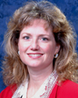

Three Women Engineers Who've Made it
and What They've Learned
Presented by SWE and Cummins
Wednesday, May 17, 2006

Natalie Givans
Vice President
Booz Allen Hamilton

Lori Cumming  Executive Director  Global Proving Grounds | Jennifer Sterling, P.E.  Director of Transmission Planning  Exelon Corporation
  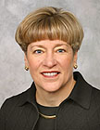
  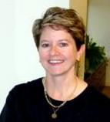

In one of the recent SWE Webinars, three successful professional women reflected on their experiences as women engineers. They stated that success came from the following things:
- Commitment to quality
- Seeking mentors and coaching
- Hard work
- Teamwork
- Willingness to take risks
- Passion for work
- Work life balance
These women pursue many passions as hobbies, but they selected math and science for their careers. Natalie Givans combines her passion for languages with an engineering degree, and she focuses her career on networks and communications. Lori Cummings started as an engineer at General Motors, and then she obtained an MBA from MIT. Lori used nontraditional family approaches such as spending only weekends together when jobs required they live at different locations. Jennifer Sterling encourages women to follow their own path and to laugh everyday.
TERESA TORRES PASSED THE PROFESSIONAL ENGINEERS EXAM FOR MECHANICAL ENGINEERING!!!!!!

Teresa sends thanks for SWE member support. SWE sends Teresa a
very BIG Congrats! Enjoy the new job on the West Side!

Six Sigma: What is it and how can it advance my career?
Presented by SWE, NSBE, SHPE and Abbott Laboratories
Wednesday, May 10, 2006
Companies use Six Sigma to drive transformation change. Raytheon went from fixing problems to using Six Sigma to come up with predictive measures to enhance performance. Six Sigma became a tool to impact designs early rather than wait for problems to happen. Corrective actions are put in place early to prevent the problems from happening.
Rusty Patterson encouraged engineers to use Six Sigma to improve their careers. A good engineer does not focus on doing the job, but rather she looks for ways to do the job better. Six Sigma means going through the process step-by-step and thinking out of the box. Ask how can we do this faster, better, safer, or cheaper?
Systems engineering would dictate that engineers identify what they want to be and then identify the requirements to get there. A critical requirement is understand how to add the most value to our employer. Engineers should position their career to provide a higher level of performance by taking advantage of the tools and applications of Six Sigma.

Time Management: How to Get It All Done and Stay Sane When You Don't!
Ruth Klein is a results-oriented Performance Strategist and “Action Coach” for business and consumer products and services in Marketing, Public Relations, Time Management, Communications, Sales, Health & Fitness, Lifestyle, and Parenting. The web seminar was presented by SWE, NSBE, SHPE and Kellogg's on June 7, 2006.

Women often see time as the enemy, because there is never enough time to get everything done. Ruth Klein suggests that the biggest time wasters are using the telephone, reading email, attending meetings, and organizing files. She keeps the cell phone turned off to avoid breaks in concentration. It is also rude to talk on the cell phone when near other people. Return calls right before lunch when people are in a hurry to go! Another trick is to wait until mid morning to check the email after you have planned your day, and only answer the critical messages.

Professionals should keep all meetings to less than 50 minutes and attendees should add items they wish to share to the agenda beforehand. Use a “month at a glance” calendar, and not a daily calendar. File papers after lunch when you are digesting your food. Use TIVO to catch up on the news, so that you don’t waste time web and channel surfing. Motorola manufactures a device called the phone trio which is reasonably priced.

Warren Buffet spends his day thinking and reading, and avoids going to meetings. Ruth advices professionals to stop multitasking, and, like Warren Buffet, sustain energy for thinking, planning, and doing. Plan ahead and integrate the different aspects of life, so have an emergency plan in place in case you can’t make it to the meeting. Be cautious about setting meeting times far in advance, because events will come up to prevent them from taking place. Value “open space” in your calendar and hold meetings in the afternoon. Morning meetings cut energy and reduce productivity for the rest of the day.

Self talk is key to effective time management. Stop several times a day and ask yourself, “what is the best use of my time right now.” Remember that the people around you have time issues too, so find out what schedules work best for them.

For most people, time management is not a time issue, it is an energy issue. Workaholics are often counterproductive, because their body gives out. Activities must be delegated or you will end up in an early grave. Procrastination does not mean you are lazy, it comes from being overwhelmed. Solve procrastination, depression, and burnout problems by doing something for yourself. Feed your body and your staff with positive talk and activities that are relaxing and refreshing.

More Events and Announcements

Congratulations to the following SWE National elected individuals
President Elect: Michelle Tortolani
Treasurer: Linette Patterson
Directors: Semahat Demir and Helen Patricia
Director of Regions: Nora Lin
COR Speaker: Melissa Tate
Region J. Governor: Linda Thomas

SWE Board Meeting
When: Wednesday, June 28, 2006
Time: 5:30 p.m.
Where: Bamboo Garden Restaurant
8021 W. Grandridge Blvd,
Kennewick (737-1688)
If interested, please attend all or part of the activity.


SWE Year End BBQ
When: Saturday, June 24, 2006
4:00 p.m. to 7:00 p.m.
Where: the Park by Wanda Munn's house
1104 Pine Street, Richland.
Bring your family and your swimsuit.
RSVP to Jennifer Reissner
(jreissne@yahoo.com) or phone 509-727-8165

Location and Directions:
The picnic will be in the fenced area adjacent to the Garden Park Pool located on the corner of Mahan and Pine Streets in Richland. Going north on George Washington Way (toward Hanford), turn left at McMurray (where Safeway is). Go past the traffic lights at Jadwin and then Stevens. The next street is Mahan. Turn right and you'll see the pool a short block in front of you. If you get lost, call Wanda's cell phone: 531-8456.

What are we going to eat?
Hamburgers and hotdogs will be provided by SWE.
Wanda has graciously volunteered her Weber grill ☺

What should I bring?
- If your last name begins with A-M, please bring veggies or a side dish.

- If your last name begins with N-Z, please bring a snack or dessert.

- Please bring your own drinks and place settings. (no alcohol or tobacco is permitted at the park)

- Bring lawn chairs or blankets if so desired.

- Your swimsuits!!! If you would like to take a dip!

Region J Conference Highlights
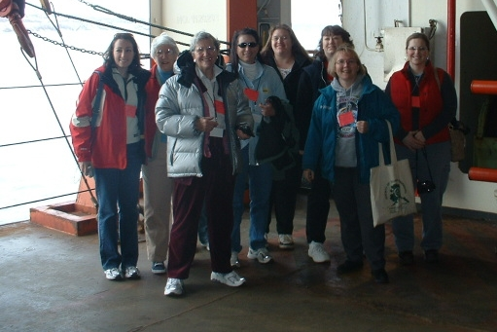

The 2006 Region J Society of Women (SWE) Conference on May 5-7 in Anchorage Alaska was financed by registration fees and a $22,000 grant from companies such as Conoco and BP Alaska. Wanda Munn, Sandy Brower, Ann Langevin, Pam Ankrum, Joan Young, Jennifer Reissner, and Renee Slocumb attended along with other local women, and there were many interesting workshops and tours for area women engineers. One of the most memorable experiences for attendee Joan Young was the keynote presentation by Libby Riddles. Libby homesteaded in Alaska just before her 17th birthday, and she soon became an accomplished musher. Libby was the first female winner of the Iditarod sled-dog race, a grueling 1,049-mile race through arctic blizzard conditions across the Alaska wilderness. Libby described mushing in blizzards and screaming as the dogs pulled the sled through narrow, steep hillsides in the Alps. Libby reminded listeners that fear and discomfort are part “really living.” Libby motivated women engineers to reach for their dream, because the joy of achieving it despite the difficulties is unsurpassed.

Lynne Curry, The Growth Company, offered advice from her management consultations and her syndicated newspaper column. Lynne recommended that engineers are more likely to be viewed as competent by the non-technical listeners if solutions address areas of strong “emotional” significance to them. Similarly, lunch keynote speaker, Jane Angvik, explained that listening is important during public involvement for development projects. You need to clearly hear not just the words, but also the values being conveyed to you by community groups who approve plans or issue permits.

The word “innovation” best describes the tours of Alaskan industries. Municipal Light and Power, an Alaska power plant, transfers the waste heat from steam generation to municipal water entering the distribution system, thereby reducing energy use for home hot water heating. North slope oil producers use 3D imaging technology to identify viscous oil deposits in existing oil wells. BP believes viscous oil recovery will sustain oil production and become the cornerstone of Alaska’s economy for the next 50 years. Alaska Department of Transportation builds “roads to nowhere," while conducting detailed planning studies on road and bridge impacts.

Loren Leman Lieutenant Governor of Alaska also spoke at the evening banquet saying “our natural treasures are the envy of the nation, but they pale in comparison to our richest resource, the people of Alaska.” Leman said he attended the meeting to thank women engineers for their contributions to the economic growth of Alaska. Job vacancies appear numerous (Workplace Alaska Jobs http://notes.state.ak.us). The pace of development in Alaska benefits Washington too. USKH (www.uskh.com) is opening an office in Walla Walla, Washington for site survey work. For those that want more adventure, BP Alaska offers North Slope Oil assignments that are two weeks per month, so that workers can live at locations inside or outside Alaska, during the remainder of the month. BP information can be found at http://www.bpfutures.com/us/.

The final day of the meeting began with a tour of TOTE, a privately-owned Alaska corporation operating a Roll-on/Roll-off cargo steamship service to Alaska between the ports of Anchorage and Tacoma. TOTE tour guides described the complexities of the shipping industry and guided engineers at the conference (see photo) through the decks and bridge of a steamship. At the close of the SWE Region J Professional Meeting, the Region Governor urged sections to maintain contact with graduates after college. A recent SWE survey showed that many female engineering students delay marriage, family, and relocating until after graduation. Female engineering graduates lose contact with SWE within 2 to 5 years after college as a result of multiple demands of both career and family. Innovative efforts are needed such as post graduation membership incentives and outreach to maintain contact with graduates after college.

Engineers Make Things Work

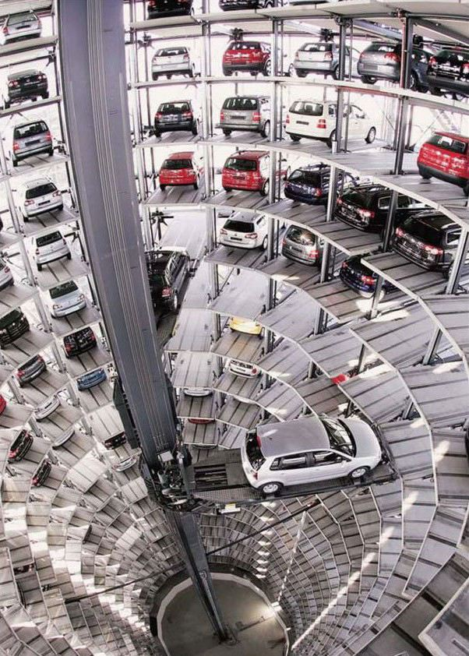
The photo was taken at a new parking garage in Munich. The actual space that the facility occupies is approximately only 20% of a comparable facility with the traditional design that is used primarily in the US. Not only is the German structure less expensive to build, but vehicles are also "retrieved" in less time and without the potential of being damaged by an attendant.

FINANCIAL PLANNING TIPS

“So far, the months of May and June have not been to kind to portfolios. Since May 10, 2006, the Dow Jones Industrial Average has lost 5.4%, the NASDAQ has lost 8.2%, and the S&P 500 has lost 5.0% (three days ago these numbers were worse). Bottom line is the economy is seeing some inflation pressures caused by oil prices, and saber rattling by Iran, the Federal Reserve indicating that they may raise interest rates at their June 28-29 meeting, as well as expiration of Options Contracts. Each year there are 2 or 3 opportunities to buy that are significantly better than other times throughout the year. As I review various indexes and ratios this may be one of those times to buy. The next few months are typically poorer performing months historically (summer months), so I expect that it may be a bit of a bumpy ride for a period of time. As always, please feel free to contact me with any questions or concerns.”
Prent C. Houck, AAMS
Financial Advisor
Piper Jaffray & Co.

Mentor a Middle School Girl via E-mail

SWE members Chrysoula (Chryssie) Nigl recently signed up for TechREACH, an after-school program that provides hands-on experiences for at-risk middle school girls in science, technology, engineering and math (STEM). TechREACH has about half the number of mentors need (have 25; need 50).

About TechREACH

The mission of TechREACH is to increase middle school girls’ interest in STEM through hands-on high-quality curriculum, mentoring and real world projects. Female professionals working in STEM-related careers mentor the girls via e-mail. Clubs will start in September 2006 and mentor training will take place starting in June.

Why E-Mentor an At-Risk Middle School Girl?
- Encourage her to continue exploring science, technology, engineering and/or math fields.
- Provide her with a caring female adult role model who listens and responds.
- Encourage her use of e-mail technology, which for many of these girls is a new experience.
- Contribute to efforts nationwide to bring more women into STEM careers.
- E-mentoring is easy and the time commitment is minimal.

TechREACH E-Mentor Commitments:
- Attend a three-hour mentor training.
- Meet your student once early in the school year. Additional activities such as club visits and field trips are optional.
- Send one e-mail each week to your student during the school year.
- Submit a brief monthly online status report.

TechREACH Club Locations:
You will have an opportunity to sign up for a particular school during the mentor training.
Pasco:
McLoughlin Middle School
Ochoa Middle School
Stevens Middle School
Sunnyside:
Harrison Middle School
Sierra Middle School

Apply online to become a TechREACH mentor, visit:
http://www.pugetsoundcenter.org/techREACH/mentors/overview.html.

Mary Burton
TechREACH Mentor Program Coordinator
Puget Sound Center for Teaching, Learning & Technology
425-368-1020 ext. 1055
mburton@pugetsoundcenter.org
www.pugetsoundcenter.org/techreach

SWE Scholarship Winners

SWE EWS scholarship activities and the Certificates of Merit happen without any fanfare. Sandy Brower and Ann Langevin have done a great job this year of not only selecting an excellent candidate for our Section scholarship, but also arranging the necessary mechanics for a new first-time-this-year generous new scholarship provided by an award from AREVA. There are 14 applicants for that stipend, and the committee will be making its decision before the end of this month. MANY THANKS to the Scholarship Committee and especially to AREVA for making this special support to a female engineer a reality.

In spring 2006, SWE EWS provided about 75 Certificates of Merit to graduating high school senior women who have shown outstanding competence in mathematics and science. All Tri City high schools and dozens of regional schools are looking to SWE every year at graduation time to provide this extra bit of recognition to the young women we hope to influence in their choice of college and career.

America Leavenworth, one of our Wanda Munn Scholarship winners, was able to attend the Region J meeting partly through contributions and support from our Section. America’s dedication is making us very proud.

Monica Hu of Kennewick, WA was the winner of a SWE National Scholarship. Monica graduated from Kamiakin High School on June 4, 2006. She will attend MIT in the fall. We wish her all the best.

SWE EWS Scholarship Selection

Tonia Gibson, WSU, Scholarship Selection

This year proved a real challenge for the EWS Scholarship Committee. In some respects it is the kind of challenge our section likes to have, and yet in other ways a difficult one, because we would like to be able to offer more than one scholarship. The applicants for our Wanda Munn 2006 Scholarship for non-traditional women in engineering were outstanding. The committee truly wished there were more scholarships to award.

Our selection was Tonia Gibson, a graduate student in Electrical Engineering at WSU with two sons, both now in college. In 2004 she received her BSEE Cum Laude from WSU where she was on the WSU President’s list in 2003 and Spring 2004. In December 2003 she was diagnosed with an aggressive form of melanoma and had surgery in Seattle followed by a year of chemotherapy. Through the surgery and chemo she carried a full load of EE classes. In January 2006 after starting her masters work the cancer returned leading to further treatment at UW Medical Center.

Expanding Your Horizons

Expanding Your Horizons took place at the WSU in Tri-Cities on May 20, 2006. About 70 middle school girls attended the event and had an opportunity to meet several professional women. The guest speaker this year was a gentleman named Mike, from LIGO, that gave a presentation about how LIGO works and expressed how important it is for girls to continue their education in math and science to open up their career opportunities. Each professional woman met with a small group of girls and explained their career and then did a hands on activity. The activities varied widely between inspecting fish, trips outside to inspect an archeological site or building bridges with toothpicks and gumdrops. Great fun as had by all!!! Many thanks to Teresa Torres and the EYH committee for all the hard work.

Happy July 4th!

A thoughtful mind, when it sees a Nation's flag, sees not the flag only, but the Nation itself; and whatever may be its symbols, its insignia, he reads chiefly in the flag the Government, the principles, the truths, the history which belongs to the Nation that sets it forth.

~ Henry Ward Beecher

Thanks to everyone who submitted information for this newsletter.

Please submit information for the next newsletter by September 20, 2006 mid-night to Joan Young.

`

About SWE
The Society of Women Engineers (SWE), founded in 1950, is a non-profit educational and service organization. SWE is the driving force that establishes engineering as a highly desirable career aspiration for women. SWE empowers women to succeed and advance in those aspirations and receive the recognition and credit for their life-changing contributions and achievements as engineers and leaders. For more information about the Society please visit www.swe.org or call (312) 596-5223. ADDRESS CORRECTION REQUESTED

Society of Women Engineers
Eastern Washington Section
P.O. Box 364
Richland, WA 99352

SWE Member

