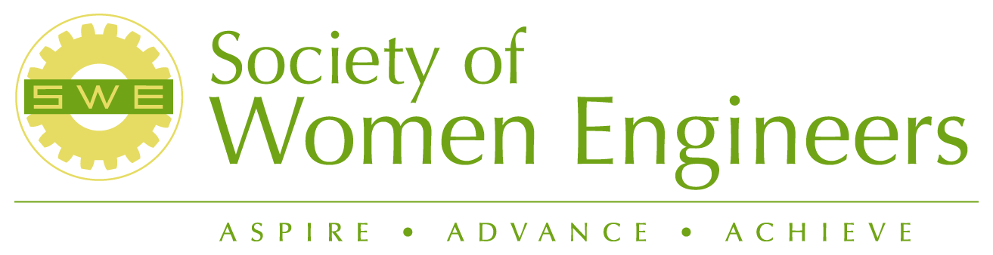 | EASTERN WASHINGTON SECTION

FY 06-07 Section Calendar
Please send additions or changes to the Calendar to joan.young@pnl.gov.
August, 2006
Aug 5, 2006 | SWE Retreat
Aug 2006 | ABJ Meeting - California

September, 2006
Sept 6, 2006 | 6:00 p.m.: Board Meeting – Location TBD

October, 2006
Oct 1, 2006 | Deadline for Newsletter Submission  EWS 30th Birthday Celebration and “The Way We Were” –  Anthony’s, Richland
Oct 3, 2006 | Walla Walla Ice Cream Social with Local Collegiate Section
Oct 4, 2006 | 6: 30 p.m.: Board Meeting – Richland Public Library
Oct. 12 – 14, 2006 | 2006 National Conference, Kansas City, MO
Oct 28, 2006 | Annual Halloween Social

November, 2006
Nov 1, 2006 | 6:30 p.m.: General Membership Meeting – Richland Public Library
Nov 11, 2006 | 8:30 a.m. SWE Breakfast Meeting – Sterling’s Restaurant, Richland
TBD | WSU and UI Ice Cream Social with Local Collegiate Section

December, 2006
Dec 9, 2006 | 6:30 pm Board Meeting and Annual Christmas Party

January, 2007
Jan 1, 2007 | Deadline for Newsletter Submission
Jan 3, 2007 | 6:30 p.m.: Board Meeting – Richland Public Library
Jan 19-21 | BJ Meeting – Las Vegas, NV
Jan 22 | Yucca Mountain Tour
TBD | Scrapbook Meeting- Wanda’s House, 1104 Pine Street, Richland
Jan 13, 2007 | 8:30 a.m. SWE Breakfast Meeting – Sterling’s Restaurant, Richland

February, 2007
Feb 7, 2007 | 6:30 p.m.: Board Meeting – Richland Public Library
Feb 10, 2007 | 8:30 a.m. SWE Breakfast Meeting – Sterling’s Restaurant, Richland
Feb 18-24, 2007 | National Engineers Week

March, 2007
TBD | Mid Columbia Science Fair
March 3, 2007 | Girl Scout Badge Day
March 7, 2007 | 6:30 p.m.: Board Meeting – Richland Public Library
Mar 10, 2007 | 8:30 a.m. SWE Breakfast Meeting – Sterling’s Restaurant, Richland

April, 2007
Apr 1, 2007 | Deadline for SWE Newsletter Submission
Apr 11, 2007 | 6:30 p.m.: General Membership Meeting, Officer Nominations – Richland Public Library
TBD | Scrapbook Meeting- Wanda’s House, 1104 Pine Street, Richland
Apr 2007 | March of Dimes: Walk America
Apr 29, 2007 | 30th Birthday Party Celebration – “Ethnic Feast”

May, 2007
May 2, 2007 | 6:00 p.m.: Board Meeting – Location TBD
May 12, 2007 | 8:30 a.m. SWE Breakfast Meeting – Sterling’s Restaurant, Richland
TBD | Expanding Your Horizons, WSU Tri-cities Campus
TBD | May, June, July: Support Airplane contest for middle schools
May 2007 | 3rd Quarter Section Report Due, Officer Nominations Due

June, 2007
Jun 2007 | 4th Quarter Section Report Due Date
Jun 6, 2007 | 6:30 p.m.: Board Meeting – Richland Public Library
Jun 29, 2007 | FY 05 Section Financial Report
Jun 30, 2007 | Quarterly Newsletter Submissions

