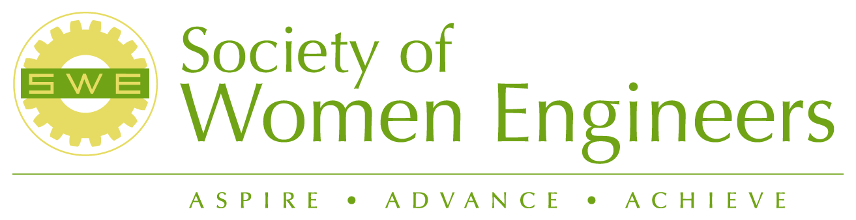

Meeting: | 8/13/2005 8:00 am-3:00 pm
Purpose: | General Retreat Meeting

Goals/ Objectives:
- Increase opportunities for members to gain leadership skills
  - Golf/casual social interaction
  - Leadership Group
  - Toastmasters Activity

- Publicize our members achievements
  - “The way we are” SWE member speakers- 1st Meeting Jennifer & Pam
  - Public presentation by members at schools (Richland Library, CBC, UI, Walla Walla)
  - Panel presentations
  - Nominate members for awards (SWE & other)
  - Identify possible engineer of year candidate

- Increase technical knowledge
  - Tours
    - Wal-Mart Distribution Center
    - Darigold
    - Smiths
    - LIGO
  - Joint meetings with other technical societies
  - Increase members technical presentations

- Diversity/Multidisciplinary
  - Publicize diversity of membership
  - Tag on national/regional diversity materials
  - Make upper level management aware that work force is “not people just like them”
  - Communication in the workplace
  - Encourage new membership

- Communicate SWE benefits to employers & potential members
  - Make employees aware of SWE resources
  - Invite/host workshops of interest to broad audience
  - Speak to other societies about how SWE is beneficial
  - Financial planning

- Advance Outreach Programs
  - Career guidance
    - September: Send letters to elementary schools requesting POCs and dates/times for engineers to visit
    - October: Send information packets for poster contest "Engineering is...." to schools
    - November, December, January: Outreach visits to schools by engineers
    - February: Poster contest judging and awarding of prizes
    - National Engineers Week at the Mall: Saturday of Engineers Week
    - March: Lessons learned;, continued outreach
    - April: Lessons learned
    - May, June, July: Support Airplane contest for middle schools
  - Expanding Your Horizons (EYH)
  - Girl Scout Badge
  - Mentoring
  - Mid-Columbia Science Fair
  - Engineers Week
  - Future City Competition

- Outreach to teachers

- Strengthen section operation
  - Strategic plans
  - Historian scrapbooking
  - Utilize experience of members
  - Fundraising→ Workshop, COM, Meet budget goals
  - Monthly Board Meetings

- Integrate collegiate members
  - Establish college contacts
  - Presenters for certificate of merit

Action Item | Responsibility | Due Date
1. Reserve restaurants for all meetings | Jennifer | ASAP
2. Contact golf course/pro for availability | Wanda | ASAP
3. Contact colleges and find out faculty & SWE president for 5 colleges | Jennifer | ASAP
4. Identify a professional member as an advisor to each college | Jennifer | ASAP
5. Set up technical tours (Wal-Mart, LIGO, Smith) | Jennifer | ASAP
6. Delegate articles for quarterly newsletter | Joan | ASAP
7. Organized presenter for Financial Planning Meeting | Joan | Jan 14th, 2006
8. Discuss and develop strategic plan | Joan & Teresa | ASAP
9. Complete program development grant (Girl Scout Badge Day) | Ann & Joan | ASAP
10. Send out brief monthly updates | Teresa | Monthly
11. Need professional development Lead | General?
12. Research Toppenish mural tour for Halloween | Jennifer | ASAP
12. SWE representative for EYH | Sandy

Attendees
Sandy Brower | Jennifer Reissner
Ann Langevin | Wanda Munn
Pam Ankrum | Jennifer Reissner
Teresa Torres

